Silver Helmsman Badge

Overview
The following are the skills a Scout needs in order to receive their Silver Helmsman Badge:
- Ropework 0
- Anchorage 2
- Water Safety 3
- Basic Sea Survival 4
- Water Activity 4
- Navigation (Coastal or Inland Waters) 5
- Rules of the Road at Sea 8
- Signalling 9
- Nautical History and Traditions 10
- Nautical Terminology 10
- Boat Maintenance and Repairs 10
- Parts of a Boat 11
- Marine Motors and Basic Maintenance 11
- Weather 12
- Currents,Tides and Wind 12
- Local Knowledge 12

Ropework
Be able to demonstrate and know the uses for the following:
- Double Sheet Bend
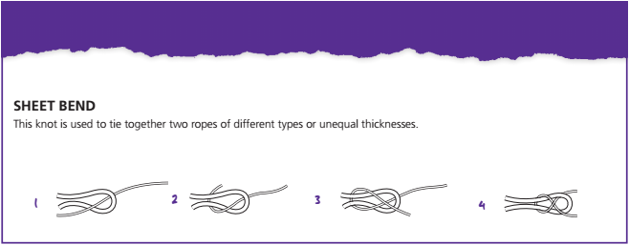
- Rolling Hitch
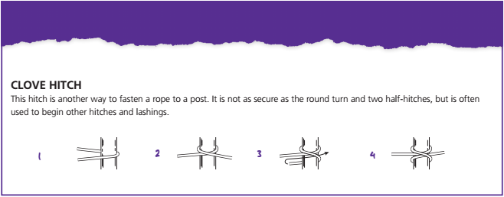

Anchorage
- Be able to des

- Be able to identify the parts of an anchor.

Water Safety
- Explain the importance of the care and use of a lifejacket or buoyancy aid.
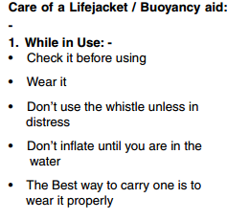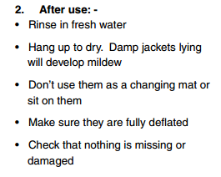
- Show how to check that a lifejacket or buoyancy aid is fit for purpose (buckles, straps, whistle etc)
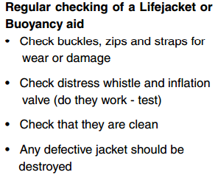

Basic Sea Survival
- List the correct personal clothing and equipment for a full day’s water activity.

Water Activity
- Identify equipment to be carried in a small craft for a day’s water activity.
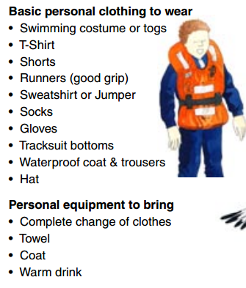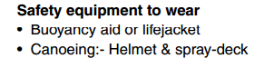

Navigation (Coastal or inland waters)
- Understand Longitude and Latitude.
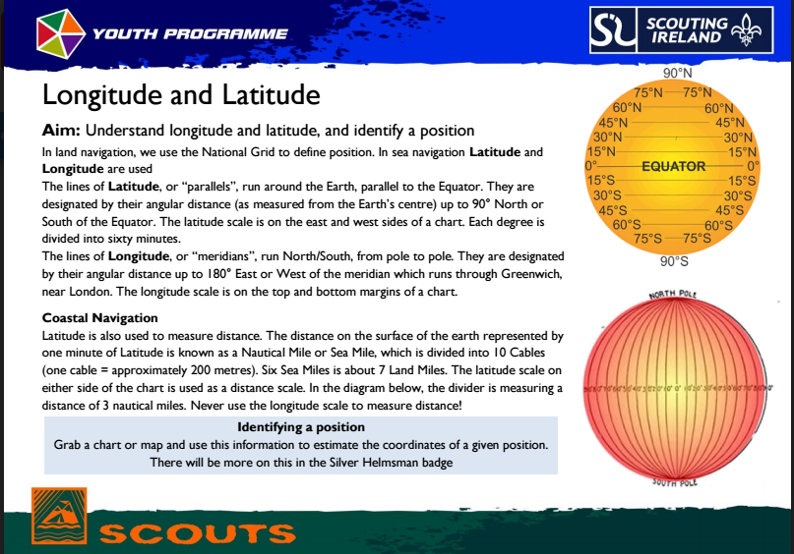
- Be able to identify a position give some co-ordinates.
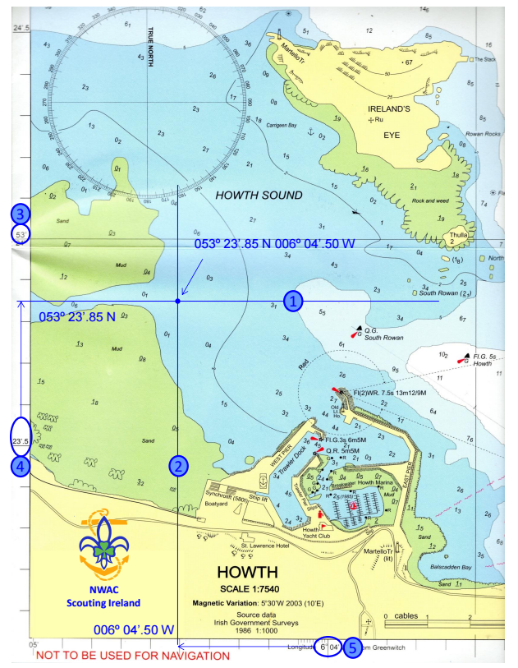
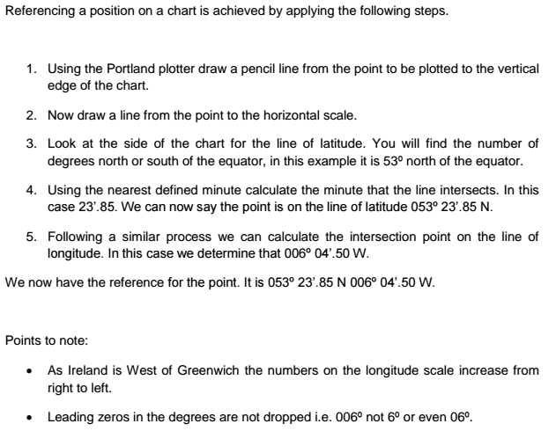
- Explain the main features and symbols on a chart.
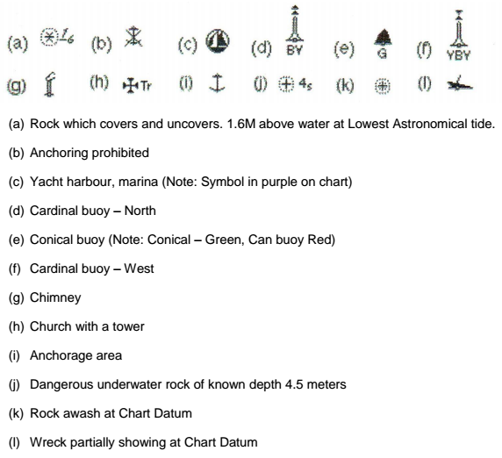

Rules of the road at sea
Know the basic rules regarding rights of way for crafts used by your troop.
- Two boats converging on the same course - Port to Port.
- Overtaking.
- Power gives way to sail.
- Paddlers give way to vessels under oars.
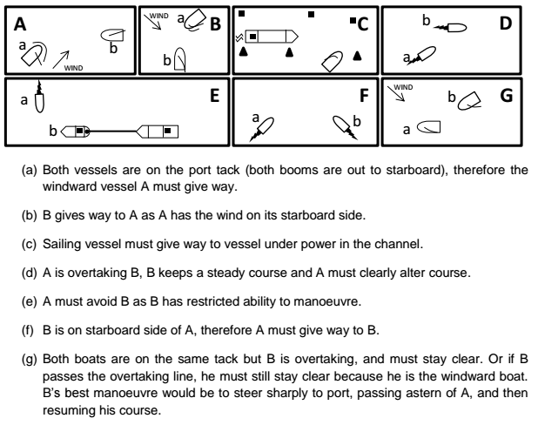

Signalling
- Discover the most common danger signals in use.
  - Flares
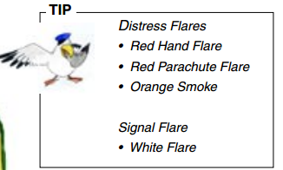

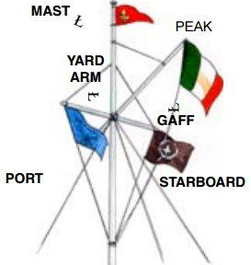
Nautical History and Traditions
- Discover what an Ensign is and where it is flown.
- How how to raise/lower a flag.
- How to carry a flag.

Nautical Terminology
Be able to identify the main terms used to denote direction from your boat.
- Forward
- Off the Port/Starboard Bow
- Abeam to Port/Starboard
- Off the Port/Starboard Quarter
- Aft
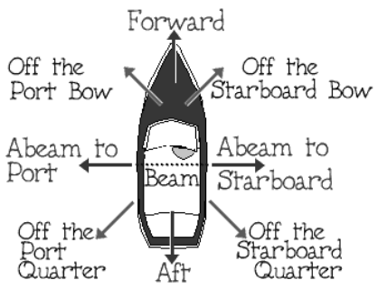

Boat Maintenance and Repairs
- Partake in at least 3 boat maintenance activities

Parts of a Boat
Be able to identify the following parts of a boat.
- Gunwhale
- Gudgeon
- Pintle
- Thwart
- Tiller
- Transom
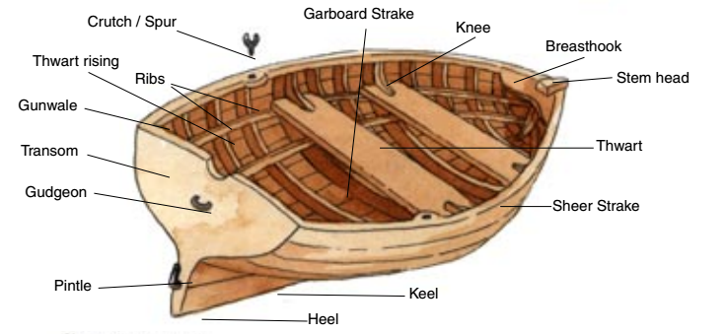

Marine Motors and Basic Maintenance
- Be aware of the basic principles of a marine engine.
- Know the difference between a 2 and 4 stroke engine.
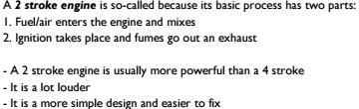
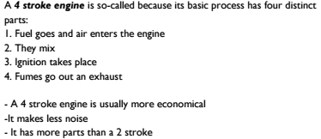

Weather
- On at least 2 occasions get the weather forecast before a water activity.
- What are the most important parts of the forecast.
- Was the forecast right and how did it affect your activity.

Currents,Tides and Wind
- Obtain tide times for your normal boating waters.
  - www.sailing.ie/tides
  - www.irishtimes.com/weather/tides
  - www.tide-forecast.com

Local Knowledge
- Know your areas water classifications.
- Obtain some local information for hazards in your normal boating waters
