BACKWOODS LEADERS NOTES – LEVELS 1-3 THEORY

Backwoods – level 1 theory
Clothes:
scout should list clothing to bring for backwoods adventure:
- for mucking about in
- for wet weather
- warm winter clothes
- clothes to cover arms – protect from sun/cuts/scratches
- headwear

Survival Kit:
Pick ten things and make up a survival kit and bring down next week (level 1 and 3)
(YOUR PARENTS ARE NOT ALLOWED TO DO THIS FOR YOU)
Suggested items for a Survival Kit (not clothes, or camping kit (e.g. sleeping bag) – useful things for when out on an adventure.
- Knife – used to cut string, chop food, (don’t bring this down next week!)  - String – used as a washing line, used to build shelter  - Tarp – used to build a shelter, or to sit on , food preparation area  - Whistle – in case you get lost  - First aid items (e.g. plasters, steri-wipes, suodocrem)  - Emergency rations (e.g. chocolate) in case you get lost or delayed and are very hungry  - Compass to find way  - Matches (waterproof ones) – for lighting fires to keep warm or cook food  - Lighter- for lighting fires to keep warm or cook food (should also have matches in case it doesn’t work)  - Pencil and paper  - Big strong Elastic bands – can be used to tie things together e.g. tripod made of thin sticks | - Plastic bag – for carrying or collecting water / or carrying rubbish  - Water purification tablets – if you run out of water you can put these in water (you have collected say from a river)to clean the water which you can then drink  - Needle and thread  - Dental floss – very strong – can be used as a washing line or as fishing line  - Fishing line – for fishing or can be used as a washing line  - Safety pins – can be used to hold various items together e.g. broken trouser zip, broken rucksack  - Mirror – to use with the sun to signal people some distance away to come and help you.  - Rope –to help build a shelter or to help you climb up steep areas  - Torch  - Survival bag – to get into if injured to keep warm, sit on if ground wet, keep your clothes dry, use as a shelter to keep dry

Fire safety:
- Dangers -do not play around fire, do not poke, keep a safe distance and obey instruction of fire tender.
- how to set a fire (choose place (not under leaves of tree, in middle grass etc, prepare ground (remove grass, put stones around in a circle to contain fire and to stop damage), what type of wood to collect (little started twigs and then bigger sticks and then logs), how to set fire e.g. with a firelighter)

Hand tools:
- Know type of tools to use on an adventure (saw, knife, spade), WHY?
- Know how to store tools away (Clean them and maybe put oil so don’t go rusty – don’t leave outside in rain, also do not store sticking out so they hurt someone)

Food preparation and safety:
- How is food cleaned and prepared without cooking utensils or preparation table (wash, cover from insects, storage, necessary to clean hands, knives and utensils to prevent infection, raw meat etc etc )
- Understand how to cook (not in flames, in embers so inside cooks, otherwise dangerous)
- Make sure food is boiled /cooked through to get rid of germs.

Backwoods – level 2 additional theory (revise all above)

First Aid:
Reassure patient:
- BE CALM. Check around for danger – make sure you are safe before approaching the person.
- Talk: say who you are and ask if you can help. If they can answer then not too bad. If no answer could be unconscious.
- Make them feel better - Tell them help on way, not to worry, etc. Tell them what you are doing.

Simple cuts:
- Clean with antiseptic wipe
- Antiseptic cream
- Cover with plaster

bleeding and bandaging:
Larger bleeds:
- Stop the bleeding – applying pressure and elevating
- Clean the wound (use medical gloves to protect yourself)
- Dress the wound:
  - Put on sterile dressing, keep in place using bandage -
  - Fold bandage/necker flat, tie in place with reef knot.
Lying patient down and elevating legs will help prevent shock and dizziness.
- Get help.

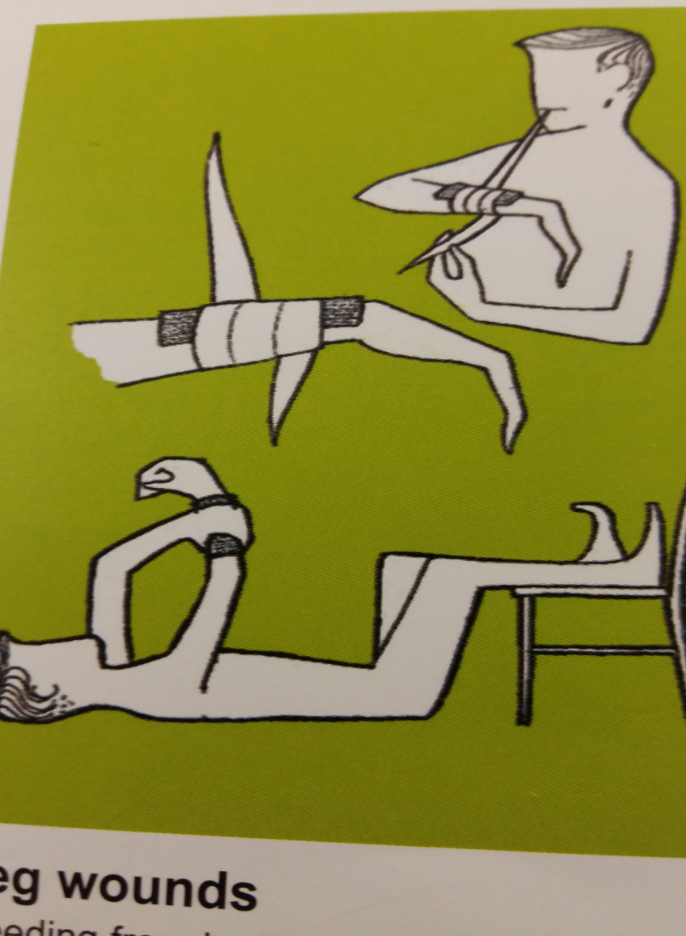

Backwoods – level 3 additional theory (- revise all above first)

Pick ten things and make up a survival kit and bring down next week (level 1 and 3)
(YOUR PARENTS ARE NOT ALLOWED TO DO THIS FOR YOU)
Weather:
How weather can affect a backwoods activity:
- What will happen if it rains in camp (tents leak, clothes get wet, muddy etc)
- What will happen if it is very hot (sunburn, dehydration, lack of energy)
- What extra gear would you bring just in case (extra tent in case one doesn’t withstand rain, extra poles in case they break, sun tan cream, cooler box etc)

Principles of leave no trace:
- Dispose of waste
- Respect farm animals and wildlife
- Minimise effect of camping and fires
- Be considerate of others
- Travel and camp on durable surfaces
- Leave what you find
- Plan ahead and prepare

First Aid:
Imagine being able to help in each of these situations – that’s what first aid is all about.

First aid - caring for injured or ill persons until they can receive professional medical care.

How to make a patient comfortable until help arrives:
STEPS/basic rules:
- BE CALM. Check around for danger – make sure you are safe before approaching the person.
- Talk: say who you are and ask if you can help. If they can answer then not too bad. If no answer could be unconscious.
- Make them feel better - Tell them help on way, not to worry, etc. Tell them what you are doing.
- Get history – what happened, where is sore,
- Get HELP – tell adult or Ring for help 999/112
- Treat the injuries (life threatening injuries first)
- Keep patient warm (basic treatment for shock and hypothermia).

How to compare injured part?.
- can patient use limb normally?
- Compare with other limb to see if swollen.
- Keep limb from moving if there is a problem.

HOW TO CALL FOR HELP: - who, where, what
- Call 999 or 112 (112 better cause international).
- WHO: State who you are and Number you are calling from (e,g in case ambulance gets lost and needs directions)
- WHERE: Location – give exact location.
- WHAT has happened, history, what injuries you can see and what you have done so far.
- Don’t hang up until told to.

REVISE level 2 – simple cuts and bandaging.

