Orienteering
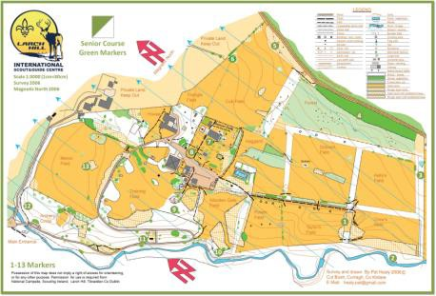
Orienteering is a sport that involves
navigation using a map and compass. You
find the control points that are indicated
on orienteering maps. You are usually
timed when orienteering so part of the
challenge is to complete the course in a
quick a time as possible.

Orienteering Maps
The Orienteering maps are of a much
greater scale than ordinance survey maps
(typically between 1:5000 and 1:15000)
the symbols are more numerous and of
more significance.

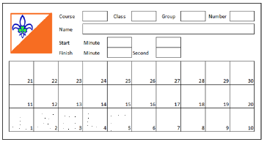
Control Cards
The standard orienteering event is a point-
to-point race; controls are numbered on
the map and connected in the order the
scout is to visit them. Upon reaching each
control, the orienteer punches a pattern in
the corresponding numbered box on the
control card. This allows the event
organisers to verify that the correct
controls were visited.

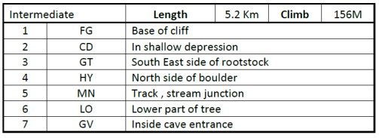
Clues Cards
The clue cards gives a clue as to what to
look for when you approach the area
marked on the map. Is the control kite at a
boulder ?, behind a tree ? or at a track,
river junction ?..

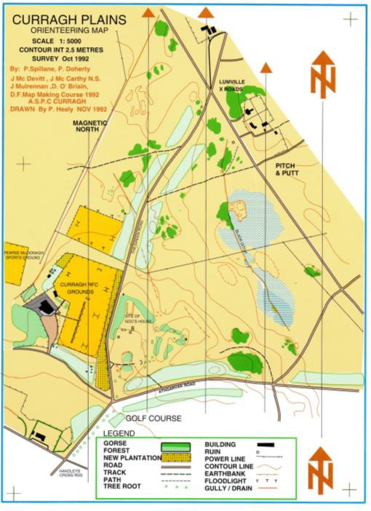Orienteering Courses
• For most orienteering events, starts
are staggered so that no two people on 6
the same course start at the same
time. 5
7
• Run around the course in order and at
the control points you will find the 4
orienteering marker. But it is up to you
to decide on your own route, use your
2 3
navigation and map-reading skills to
plan the most effective route.

1
• Pay particular attention to the type of
vegetation, contours and paths/trails.
• Remember that the scale is different to
standard maps.

• Check the clue card to ensure that the code written on the marker is the correct one and then stamp the appropriate box on the control card with the control punch.

• Quickly move on to the next control.
Continue from control to control until
you reach the finish.

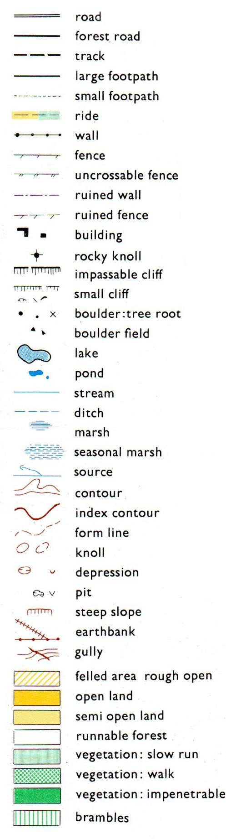
Orienteering Symbols
As orienteering maps are very detailed,
they need to have a large range of symbols
to accurately show what the place is like.

• Black symbols are used for rock features (eg: boulders, cliffs, stony ground) and for linear features (eg: roads, paths and fences), as well as for other human- made features.
• Brown symbols are used for landforms such as contour lines, small knolls, ditches & earth banks.
• Blue is used to mark water features: such as lakes, ponds, rivers, streams and marshes.
• Magenta shows the route, the control points and the start and finish.

Accessibility:
Different background colours are used to
show how accessible or runnable an area
should be:
• Yellow is to designate vegetation -
specifically open or un-forested land.
• Green is used to show vegetation that
slows down the passage of an orienteer.
• Dark green areas, called "fight", are
usually impassable.
• White signifies forest with little or no
undergrowth - forest that you can run
through.
• Purple (or red) is used to mark the
orienteering course on a map. Also, to
designate map corrections and out-of-
bounds areas.

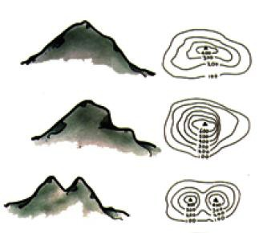
Orienteering and Countours Orienteering maps make extensive use of contour lines. These typically brown lines are created by an imaginary line along which every point is the same distance above sea level. By looking at your map you can determine whether the mountain
has a steep slope (contours close together)
or a gentle slope ( contours spread apart).

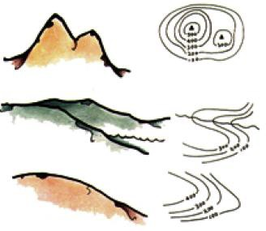
For orienteering maps the typical contour interval is 5M, this compares to a 10M interval on most ordinance survey maps. In the example to the below we can clearly see a spur with mixed vegetation flowing from left to right.

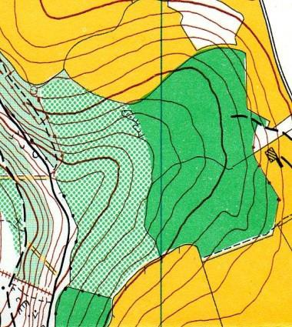
When orienteering, you can use contours to plan your route. Sometimes it is quicker to go around and other times it may be quicker to climb or descend a feature. Contours are also important in helping you located points, is the next marker higher or lower than where you are? Does the path start to rise or fall before you reach it?

