Hiking 1&2
How to pack rucksack:
Have a list and check it off as you put things in rucksack.
Distribute the weight so usually comfortable if heavy things are near the bottom
Remember principle – last in, first out - need to be accessible quickly
- rain gear, hats and gloves (on top).
- put water in side pockets perhaps so wont spill on clothes and easy to get.
- lunch in middle
- spare clothes down bottom
NB – ruck sacks are never waterproof so put everything in survival bag or garbage bag.

What clothes to bring: What do you need for rain, wind and sun?
Rain gear-jacket and trousers
Hat/gloves/sunhat/
Extra layers of clothes and Spare pair of socks (in plastic bag to keep dry)
NB: do not wear jeans, too cold when wet can get hypothermia

Other things to bring:
Pack all in a survival bag/bin liner to keep dry from rain (also good if accident and need to keep warm and dry)
Whistle and torch for emergencies
Sun tan cream & mosquito spray (if needed)
If a leader then need:
Mobile phone, first aid kit, survival kit, sleeping bag (for emergency use)
Map & compass

FOOD:
Lunch – sandwiches –carbs
Snacks = high energy – nuts. Dried fruit, choclate
soup to keep warm (in a flask!), lots of water for hydration –
emergency ration e.g. chocolate bar (not to be eaten until in an emergency or hike finished)
Level 2: Explain – food pyramid

HOW TO BE SAFE
Buddy system
keep up
walk carefully over rough ground
Listen to leaders – aware of dangers
be responsible part of team
International distress signal:
- Six good long blasts on whistle/ six shouts/ six flashes of torch, followed by pauses of 1 minute and then repeat.
- This should be used so that rescuers can find you. If heard they will reply with burts of 3 signals instead of six.
- Keep signally cause they need to find you.
- Only use in emergencies e.g. when you are unable to get off a mountain due to injury.

Map Features: should know:
- introduce scale
- show North, E, S and W
- main items on a OS map legend, eg forest, track, road, water etc
- height colouring (see on side of map usually),
- point out top of a mountain with height written on it.
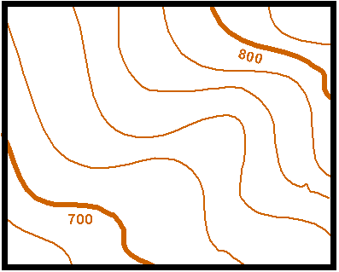
- contour lines –
  - show the height and shape of land
  - usually 10 metres between them
  - spread out means gradual ascent
  - tight together means very steep

LEVEL 1 only: I can read a simple map – kids should be able to follow map below and be able to orientate it (ie point it in direction they are going – or pretending to go).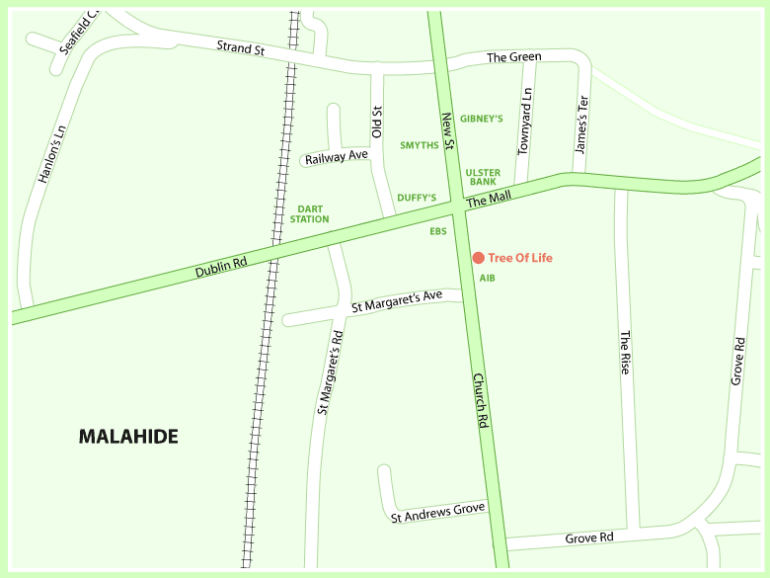
Level 2 only: know main parts of a compass – (leave out number 4 and 6 below)
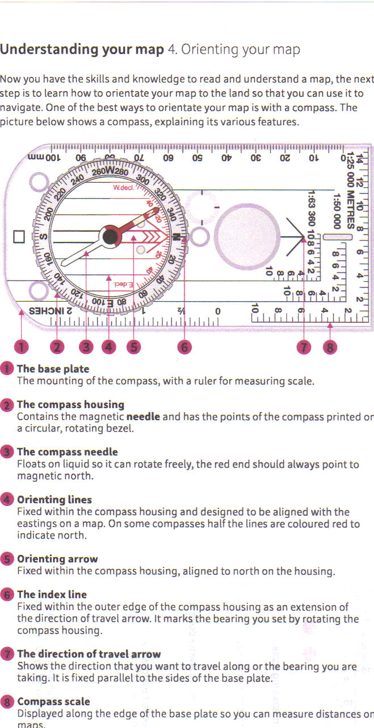

Level 2 only: Weather forecasts
why do we need them? mountains have localised weather patterns – Windchill, more rain,
colder at altitude, fog, storms etc all present danger – need to be prepared – or may need to cancel.

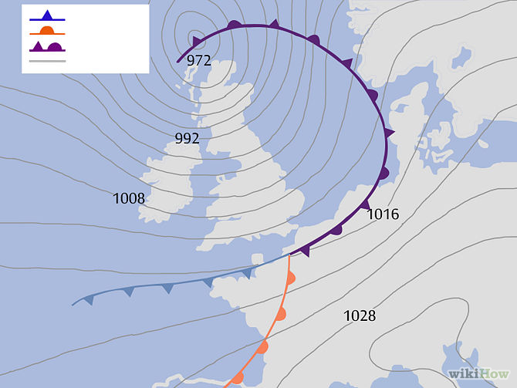

FRONTS: mark the boundary between warmer air on one side and colder air on the other. If you are close to a front and you know the front is moving towards you, you can expect a change in weather (e.g. cloud formation, rain, wind) when the front boundary passes over you.

- Cold front: - Blue line with triangles; rainfall and wind speeds can be high. The direction the triangles point is the direction in which the cold front is moving.

- Warm front: - Red line with semi-circles; Often brings a gradual increase in rainfall as the front approaches, followed by prompt clearing and warming after the front passes. The side of semi-circles represents direction it is heading.

- Occluded front: - A purple line with semi-circles and triangles; Formed when a cold front overtakes a warm front. Associated with various weather events (possibly thunderstorms). The passing of an occluded front usually brings drier air. Whichever side the shapes are on, is the direction the occluded front is going.

- Stationary front: - A semi-circle bordering one side and triangles along the opposite side; represents that the front is not moving in any direction, ie non-moving boundary between two different air masses. These fronts have long continuous rainy periods
Weather forecast sources:
television
RTE radio 1
Met eireann - www.met.ie
web e.g. http://www.yr.no , www.windguru.cz
newspaper
shipping forecast
Level 2: Emergencies
STEPS/basic rules:
- BE CALM. Check around for danger – make sure you are safe before approaching the person.
- Talk: say who you are and ask if you can help. If they can answer then not too bad. If no answer could be unconscious.
- Make them feel better - Tell them help on way, not to worry, etc. Tell them what you are doing.
- Get history – what happened, where is sore
- Get HELP – tell adult or Ring for help 999/112
- Treat the injuries (life threatening injuries first)
- Keep patient warm (basic treatment for shock and hypothermia).

HOW TO CALL FOR HELP: - who, where, what
- Call 999 or 112 (112 better cause international).
- WHO: State who you are and Number you are calling from (e,g in case ambulance gets lost and needs directions)
- WHERE: Location – give exact location.
- WHAT has happened, history, what injuries you can see and what you have done so far.
- Don’t hang up until told to.

Different emergency services:
- Guards
- Coastguard
- Mountain rescue
- Ambulance
- Fire-brigade

