Hiking 3
How to pack rucksack - recap
Have a list and check it off as you put things in rucksack.
Distribute the weight so usually comfortable if heavy things are near the bottom
Remember principle – last in, first out - need to be accessible quickly
- rain gear, hats and gloves (on top).
- put water in side pockets perhaps so wont spill on clothes and easy to get.
- lunch in middle
- spare clothes down bottom
NB – ruck sacks are never waterproof so put everything in survival bag or garbage bag.

Other things to bring:
Pack all in a survival bag/bin liner to keep dry from rain (also good if accident and need to keep warm and dry)
Whistle and torch for emergencies
Sun tan cream & mosquito spray (if needed)
If a leader then need:
Mobile phone, first aid kit, survival kit, sleeping bag (for emergency use)
Map & compass

What clothes to bring: What do you need for rain, wind and sun?
outershell - Rain gear-jacket and trousers – qualities – waterproof, windproof and breathable –why?
layers of clothes –why? – trap air, keeps warmer ,control of body heat and ventilation -
– explain wicking
Hat/gloves/sunhat/
Spare pair of socks (in plastic bag to keep dry) –
NB: do not wear jeans, too cold when wet can get hypothermia

Leave no trace - recap
- Dispose of waste
- Respect farm animals and wildlife
- Minimise effect of camping and fires
- Be considerate of others
- Travel and camp on durable surfaces
- Leave what you find
- Plan ahead and prepare

International distress signal:
- Six good long blasts on whistle/ six shouts/ six flashes of torch, followed by pauses of 1 minute and then repeat.
- This should be used so that rescuers can find you. If heard they will reply with burts of 3 signals instead of six.
- Keep signally cause they need to find you.
- Only use in emergencies e.g. when you are unable to get off a mountain due to injury.
Ground:
- how to cross boggy ground – stay on tufts, place foot deliberately and test out if sinking before placing weight, don’t jump – twist ankle
- dangers of steep ground - traverse so easier going uphill, and helps with force on knees going downhill , don’t run downhill – will stumble,– twist ankle,
- dangers of rugged rocky ground – if stumble can twist ankle, don’t jump – twist ankle, , place feet deliberately,
- dangers of remoteness – if in trouble, hard to find, no phone coverage, longer to get back etc

1st aid – recap – briefly – should already have L2/l3 1st aid
STEPS/basic rules:
- BE CALM. Check around for danger – make sure you are safe before approaching the person.
- Talk: say who you are and ask if you can help. If they can answer then not too bad. If no answer could be unconscious.
- Make them feel better - Tell them help on way, not to worry, etc. Tell them what you are doing.
- Get history – what happened, where is sore
- Get HELP – tell adult or Ring for help 999/112
- Treat the injuries (life threatening injuries first)
- Keep patient warm (basic treatment for shock and hypothermia).

HOW TO CALL FOR HELP: - who, where, what
- Call 999 or 112 (112 better cause international).
- WHO: State who you are and Number you are calling from (e,g in case ambulance gets lost and needs directions)
- WHERE: Location – give exact location.
- WHAT has happened, history, what injuries you can see and what you have done so far.
- Don’t hang up until told to.

- how to clean wound
- how to apply bandage

Maps :
- recap - How to read grid refs and:
- recap - Map Features: should know:
- introduce scale
- show North, E, S and W
- main items on a OS map legend, eg forest, track, road, water etc
- height colouring (see on side of map usually),
- point out top of a mountain with height written on it.
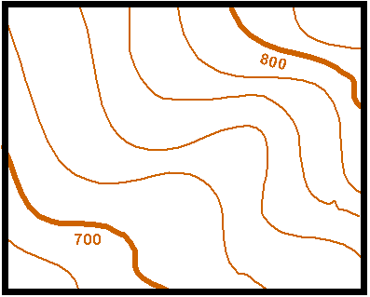
- contour lines –
  - show the height and shape of land
  - usually 10 metres between them
  - spread out means gradual ascent
  - tight together means very steep

Compass bearings:
1) recap – parts – base plate, compass housing, compass needle, orienting lines, orienting arrow, the direction of travel arrow, compass scale
2) how to take compass bearings and how to follow a bearing – see additional documentation
main parts of a compass – (leave out number 4 and 6 below)
