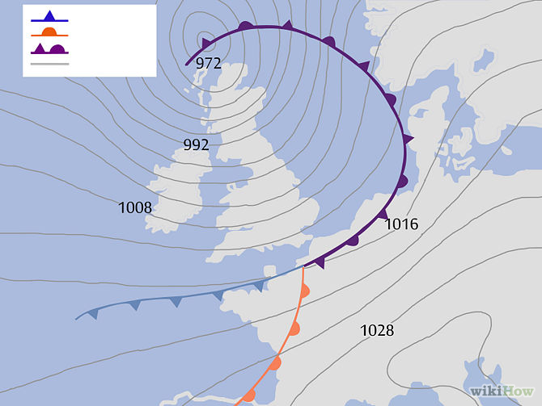

FRONTS: mark the boundary between warmer air on one side and colder air on the other. If you are close to a front and you know the front is moving towards you, you can expect a change in weather (e.g. cloud formation, rain, wind) when the front boundary passes over you.

- Cold front: - Blue line with triangles; rainfall and wind speeds can be high. The direction the triangles point is the direction in which the cold front is moving.
- Warm front: - Red line with semi-circles; Often brings a gradual increase in rainfall as the front approaches, followed by prompt clearing and warming after the front passes. The side of semi-circles represents direction it is heading.
- Occluded front: - A purple line with semi-circles and triangles; Formed when a cold front overtakes a warm front. Associated with various weather events (possibly thunderstorms). The passing of an occluded front usually brings drier air. Whichever side the shapes are on, is the direction the occluded front is going.
- Stationary front: - A semi-circle bordering one side and triangles along the opposite side; represents that the front is not moving in any direction, ie non-moving boundary between two different air masses. These fronts have long continuous rainy periods
Weather forecast sources:
television
RTE radio 1
Met eireann - www.met.ie
web e.g. http://www.yr.no , www.windguru.cz
newspaper
shipping forecast

when using web usually need to enter the area you want in a search box.
http://www.windguru.cz/ - good for wind – 3 readings – for non subscribers there will be a lag of 12 hours so be careful.
http://www.yr.no – Nordic weather forecasting –good
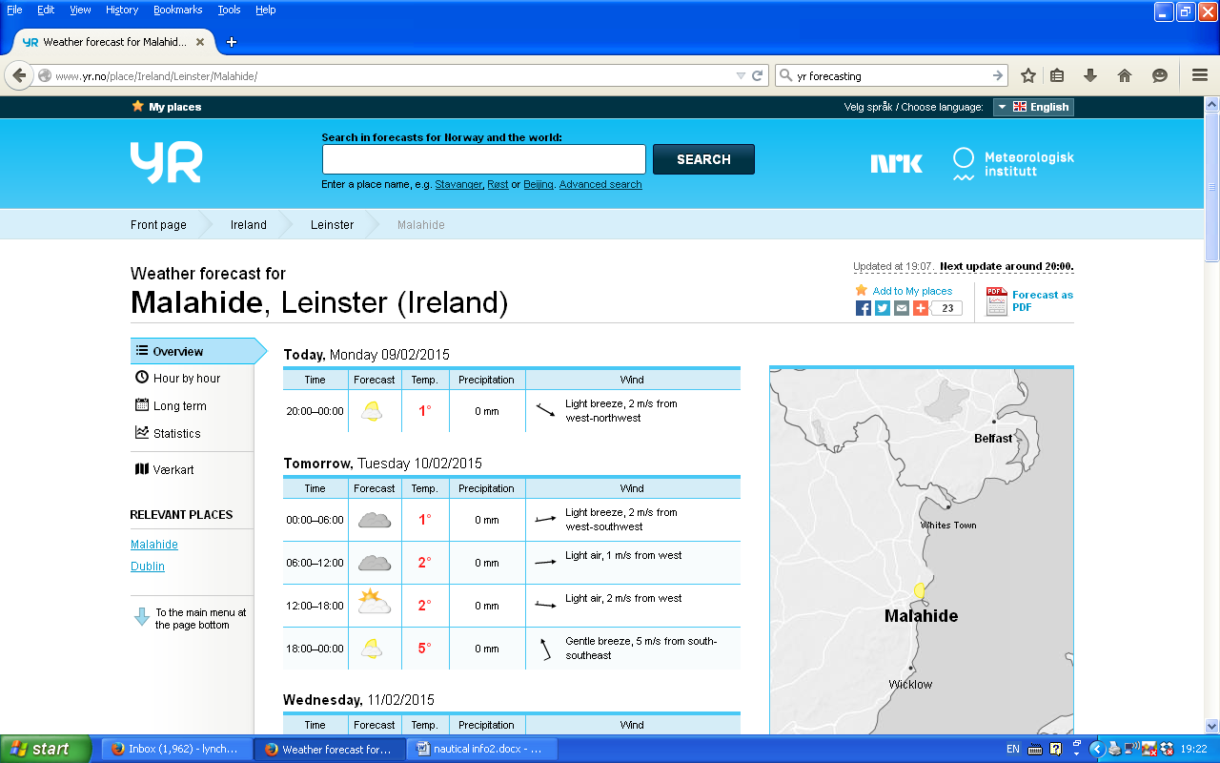
On Tuesday, between 6am-12pm it will be raining, it will be 2°C, there will be no rain, light winds from west.

